

**Placement Empowerment Program**

***Cloud Computing and DevOps Centre***

Host a Static Website on a Cloud VM Install Apache on your cloud VM and host a simple HTML website.

**Name: VIJAYA NANDANA M Department : CSE**

**Introduction**

A static website serves pre-written HTML, CSS, and JavaScript files to the end user without requiring server-side processing. Hosting such websites on a cloud-based Virtual Machine (VM) has become a preferred choice for individuals and businesses due to its flexibility, scalability, and cost-effectiveness. By leveraging the cloud, developers can quickly deploy websites accessible from anywhere in the world.

**Objectives**

* Learning Cloud Computing Fundamentals: Understanding how virtual machines operate in a cloud environment.
* Practical Web Hosting Skills: Gaining hands-on experience in setting up and configuring web servers like Apache or Nginx.
* Website Deployment: Successful

**Step by Step Overview**

**1.** Have an HTML file (with any related assets like CSS/JavaScript) that you want to host in your GitHub repository.

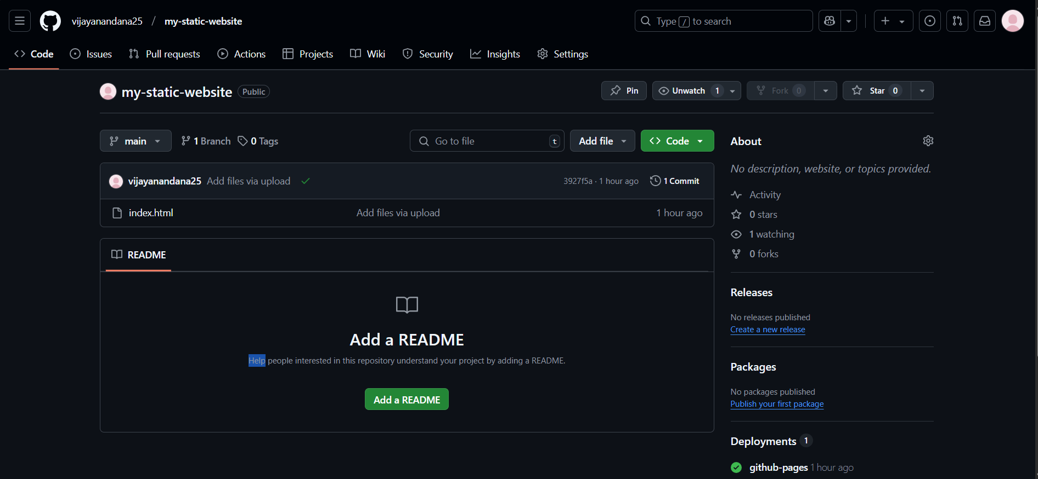

**2. Create a EC2 server**

Launch an EC2 instance, select Ubuntu as the OS, configure security groups to allow all network traffic, create a key pair (e.g., new.pem), and download it for SSH access.

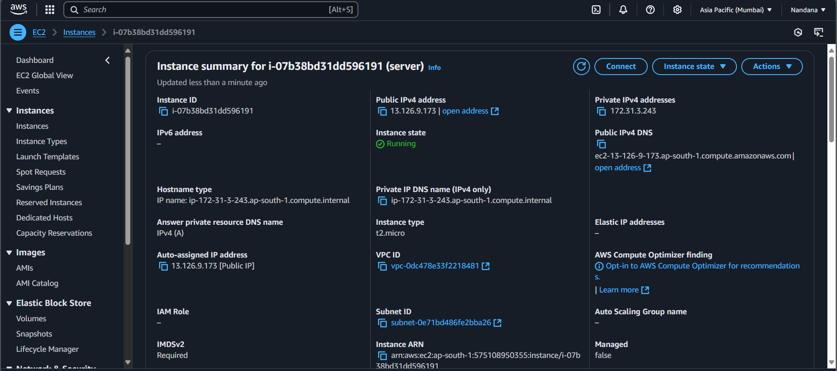

### **3. Connect**

### Click the 'Connect' option on your launched instance, go to the SSH client section, and copy the command provided under the 'Example' section.

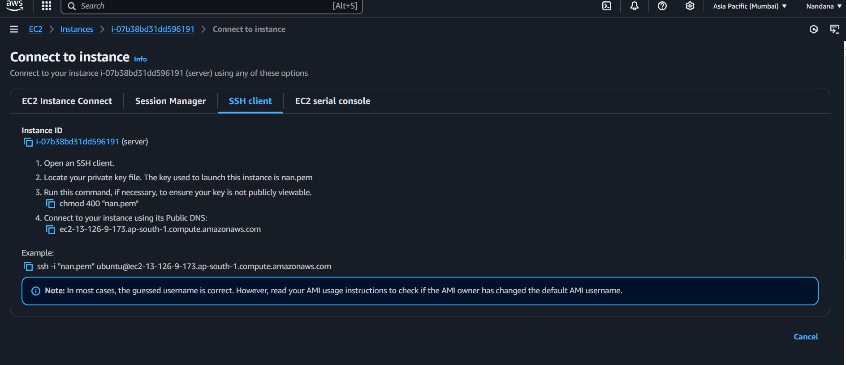

**4. Open Power Shell**

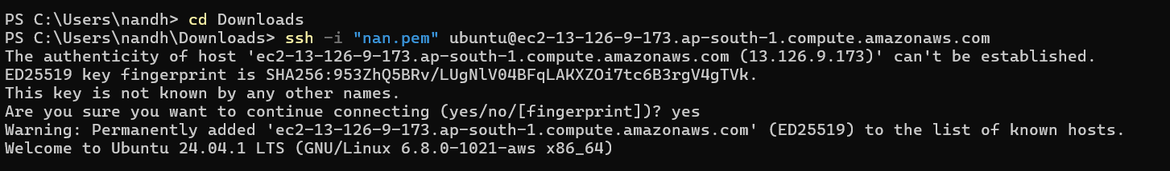

**5. Run the following commands**

Run the command **sudo apt update** to update the package list.



Run the command **sudo apt upgrade**, and press 'Y' to confirm and continue the upgrade process.

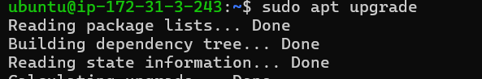

Install the Apache server by running the command **sudo apt install apache2**, and press 'Y' to confirm the installation

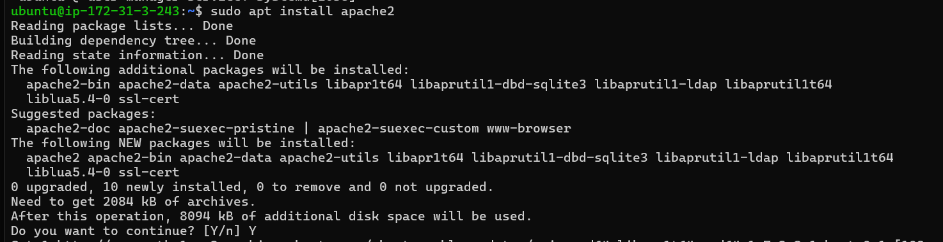

Insert your files by running the command **git clone** to clone your repository containing the website files.

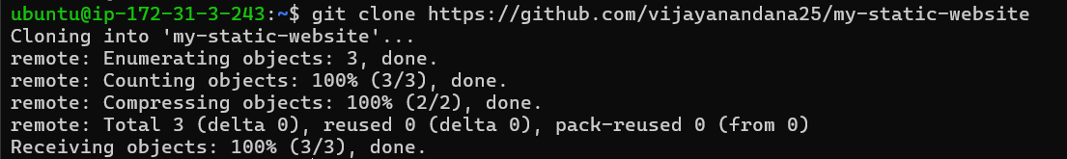

Run the command **cd /var/www/html** to navigate to the web server's root directory, then type ls to verify that your HTML files from the GitHub repository are present.



**6. Execute**

Copy the **Public IPv4 DNS** from the instance details page in the EC2 console and paste it in URL.

**Outcome:**

With this PoC, we learn to access your static website live on the web using the EC2 instance's Public IPv4 DNS.